Data Structures and Algorithm using Python
Program 1:

Aim:

To write a Python program to find the factorial of a given number using Linear recursion

Algorithm:

Step 1: Start the program.

Step 2: Define a function factorial(n).

Step 3: If n is equal to 0 or 1, return 1.

Step 4: Otherwise, return n × factorial(n − 1).

Step 5: Define a function repeat().

Step 6: Ask the user whether to continue (yes or no).

Step 7: If the user enters yes:
- Read an integer n
- Call the factorial(n) function
- Display the factorial of n
- Call the repeat() function again

Step 8: If the user enters no, display "Program Stopped".

Step 9: Read an integer n from the user.

Step 10: Call the factorial(n) function and store the result.

Step 11: Display the factorial of n.

Step 12: Call the repeat() function.

Step 13: Stop the program.

Program:

def factorial(n):
if n == 0 or n == 1:
return 1
else:
return n * factorial(n - 1)

def repeat():
a = input("\nDo you want to continue yes or no : ")
if a == "yes":
n = int(input("Enter a number: "))
result = factorial(n)
print("Factorial of", n, "is", result)
repeat()
else:
print("Program Stopped")

n = int(input("Enter a number: "))
result = factorial(n)
print("Factorial of", n, "is", result)
repeat()

Output:

Enter a number: 5
Factorial of 5 is 120

Do you want to continue yes or no : yes
Enter a number: 6
Factorial of 6 is 720

Do you want to continue yes or no : no
Program Stopped

Result:

The Python program to find the factorial of a given number using Linear recursion was executed successfully.

-----------------------------------------------------------------------------------------------

Program 2:

Aim:

To write a Python program to find the Fibonacci value of a given number using binary recursion.

Algorithm:

Step 1: Start the program.

Step 2: Define a function fibonacci(n).

Step 3: If n is equal to 0 or 1, return 1.

Step 4: Otherwise, return fibonacci(n − 1) + fibonacci(n − 2).

Step 5: Define a function repeat().

Step 6: Ask the user whether to continue (yes or no).

Step 7: If the user enters yes:
- Read an integer n
- Call the fibonacci(n) function
- Display the Fibonacci value of n
- Call the repeat() function again

Step 8: If the user enters no, display "Program Stopped"

Step 9: Read an integer n from the user.

Step 10: Call the fibonacci(n) function and store the result.

Step 11: Display the Fibonacci value of n.

Step 12: Call the repeat() function.

Step 13: Stop the program.

Program:

def fibonacci(n):
if n == 0 or n == 1:
return 1
else:
return fibonacci(n - 1) + fibonacci(n - 2)

def repeat():
a = input("\nDo you want to continue yes or no : ")
if a == "yes":
n = int(input("Enter a number: "))
result = fibonacci(n)
print("Fibonacci of", n, "is", result)
repeat()
else:
print("Program Stopped")

n = int(input("Enter a number: "))
result = fibonacci(n)
print("Fibonacci of", n, "is", result)
repeat()

Output:

Enter a number: 5
Fibonacci of 5 is 8

Do you want to continue yes or no : yes
Enter a number: 6
Fibonacci of 6 is 13

Do you want to continue yes or no : no
Program Stopped

Result:

The Python program to find the Fibonacci value of a given number using Binary recursion was executed successfully.

-----------------------------------------------------------------------------------------------

Program 3:

Aim:

To write a Python program to perform stack operations such as push (add), pop (remove), and display using a menu-driven approach with overflow and underflow conditions.

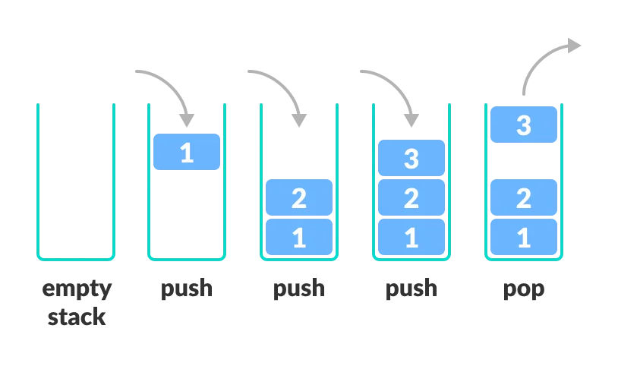
Algorithm:

Step 1: Start

Step 2: Define a class Stack_Adt

Step 3: Define the constructor __init__()

- Initialize an empty list stack
- Read the stack size (limit) from the user

Step 4: Define the Push() method to insert elements into the stack
- Step 4.1: Check whether the stack size has reached its limit
- Step 4.2: If the stack is full, display “Stack Overflow”
- Step 4.3: Else, read items from the user
- Step 4.4: Insert each item into the stack using append()
- Step 4.5: Display the updated stack

Step 5: Define the Pop() method to remove an element from the stack
- Step 5.1: Check whether the stack is empty
- Step 5.2: If empty, display “Stack Underflow”
- Step 5.3: Else, remove the top element using pop()
- Step 5.4: Display the updated stack

Step 6: Define the disp() method to display stack elements
- Step 6.1: Check whether the stack is empty
- Step 6.2: If empty, display “Stack Underflow”
- Step 6.3: Else, display all elements of the stack

Step 7: Define a function rep() to perform menu-driven stack operations
- Step 7.1: Display menu options
  - 1 → Push
  - 2 → Pop
  - 3 → Display
  - 4 → Exit
- Step 7.2: Read the user’s choice
- Step 7.3: Perform the selected operation
- Step 7.4: Repeat until the user selects Exit

Step 8: Create an object s of class Stack_Adt

Step 9: Call the rep() function

Step 10: Ask the user whether to continue
- Step 10.1: If user enters Y, repeat the process
- Step 10.2: If user enters N, stop the stack process
- Step 10.3: Else, display “Invalid Typing”

Step 11: Stop

Program:

class Stack_Adt:
def __init__(self):
self.stack=[]
self.size=int(input("Enter the limit:"))

def Push(self):
if len(self.stack)>=self.size:
print("The Stack is Overflow:")
else:
for i in range(0,self.size):
item=input("Enter the item:")
self.stack.append(item)
print(f"Given item is Pushed:=>{item}")

def Pop(self):
if len(self.stack)==0:
print("Stack is Underflow:")
else:
g=self.stack.pop()
print(f"Given item is Popped:=>{g}:")

def disp(self):
if len(self.stack)==0:
print("Stack is Underflow")
else:
print(f"The current Stack:{self.stack}")

def rep():
while True:
print("\nGiven Choices are available\n1 is Push Function\n2 is Pop Function\n3 is Display Function\n4 is Exit the process")
f=int(input("\nEnter the Choice:"))
if f==1:
s.Push()
elif f==2:
s.Pop()
elif f==3:
s.disp()
elif f==4:
print("Exit the Process:")
break

s=Stack_Adt()
rep()

while True:
d=input("\nDo you want to continue (Y or N) :")
if d=="y" or d=="Y":
rep()
elif d=="n" or d=="N":
print("The Stack Process was Stopped!")
break
else:
print("Invalid Typing")

Output:

Enter stack size: 3

a - Add element
r - Remove element
d - Display stack
e - Exit

Enter your choice: a
Enter your item: 1
Item inserted: 1

a - Add element
r - Remove element
d - Display stack
e - Exit

Enter your choice: a
Enter your item: 2
Item inserted: 2

a - Add element
r - Remove element
d - Display stack
e - Exit

Enter your choice: a
Enter your item: 3
Item inserted: 3

a - Add element
r - Remove element
d - Display stack
e - Exit

Enter your choice: a
Stack Overflow! Cannot insert item.

a - Add element
r - Remove element
d - Display stack
e - Exit

Enter your choice: d
Current Stack: ['1', '2', '3']

a - Add element
r - Remove element
d - Display stack
e - Exit

Enter your choice: r
Item removed: 3

a - Add element
r - Remove element
d - Display stack
e - Exit

Enter your choice: r
Item removed: 2

a - Add element
r - Remove element
d - Display stack
e - Exit

Enter your choice: r
Item removed: 1

a - Add element
r - Remove element
d - Display stack
e - Exit

Enter your choice: r
Stack Underflow! Stack is empty.

a - Add element
r - Remove element
d - Display stack
e - Exit

Enter your choice: e
The stack operation is stopped!
Do you want to continue yes or no : no
The stack operation stopped

Result:

The Python program to perform stack operations such as push, pop, is empty, is full, and display using a list was executed successfully.

------------------------------------------------------------------------------------------------

Program 4:

Aim:

To write a Python program to perform queue operations such as enqueue (add), dequeue (remove), and display using a menu-driven approach with overflow and underflow conditions.
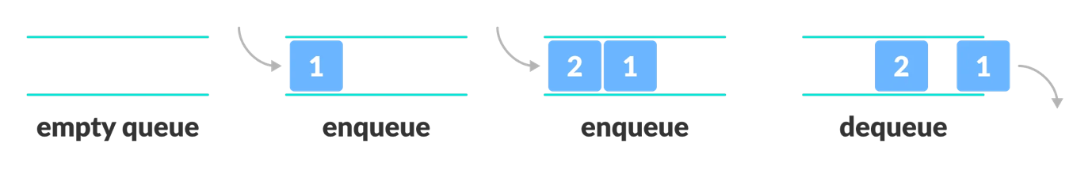
Algorithm:

Step 1: Start

Step 2: Define a class Queue_Adt

Step 3: Define the constructor __init__()
- Initialize an empty list queue
- Read the queue size (limit) from the user

Step 4: Define the Enqueue() method to insert elements into the queue
- Step 4.1: Check whether the queue has reached its maximum size
- Step 4.2: If the queue is full, display “Queue is Full”
- Step 4.3: Else, read items from the user
- Step 4.4: Insert each item at the rear of the queue using append()
- Step 4.5: Display the updated queue

Step 5: Define the Dequeue() method to remove an element from the queue
- Step 5.1: Check whether the queue is empty
- Step 5.2: If empty, display “Queue is Empty”
- Step 5.3: Else, remove the front element using pop(0)
- Step 5.4: Display the updated queue

Step 6: Define the disp() method to display queue elements
- Step 6.1: Check whether the queue is empty
- Step 6.2: If empty, display “Queue is Empty”
- Step 6.3: Else, display all elements of the queue

Step 7: Create an object s of class Queue_Adt

Step 8: Define a function rep() to perform menu-driven queue operations
- Step 8.1: Display menu options
  - 1 → Enqueue
  - 2 → Dequeue
  - 3 → Display
  - 4 → Exit
- Step 8.2: Read the user’s choice
- Step 8.3: Perform the corresponding queue operation
- Step 8.4: Repeat until the user selects Exit

Step 9: Call the rep() function

Step 10: Ask the user whether to continue
- Step 10.1: If the user enters yes, repeat the process
- Step 10.2: If the user enters no, stop the queue process
- Step 10.3: Else, display “Invalid Typing”

Step 11: Stop

Program:

class Queue_Adt:
def __init__(self):
self.queue=[]
self.size=int(input("Enter the limit:"))

def Enqueue(self):
if len(self.queue)>=self.size:
print("The Queue is Full:")
else:
for i in range(0,self.size):
item=input("Enter the item:")
self.queue.append(item)
print(f"Given item is Added the Queue:=>{item}")

def Dequeue(self):
if len(self.queue)==0:
print("Queue is Empty:")
else:
g=self.queue.pop(0)
print(f"Given item is Removed the Queue:=>{g}:")

def disp(self):
if len(self.queue)==0:
print("Queue is Empty")
else:
print(f"The current Queue:{self.queue}")

s=Queue_Adt()

def rep():
while True:
print("Given Choices are available\n1 is Adding the Element in Queue \n2 is Removing Element in Queue\n3 is Display the Queue\n4 is Exit the process")
f=int(input("Enter the Choice:"))
if f==1:
s.Enqueue()
elif f==2:
s.Dequeue()
elif f==3:
s.disp()
elif f==4:
print("Exit the Process:")
break
rep()
while True:

d=input("Do you want to continue?:\nType yes or no:")
if d=="yes":
rep()
elif d=="no":
print("The Queue Process was Stopped!")
break
else:
print("Invalid Typing")

Output:

Enter the limit:2

Given Choices are available
1 is Adding the Element in Queue
2 is Removing Element in Queue
3 is Display the Queue
4 is Exit the process

Enter the Choice:1
Enter the item:1
Given item is Added the Queue:=>1
Enter the item:2
Given item is Added the Queue:=>2

Given Choices are available
1 is Adding the Element in Queue
2 is Removing Element in Queue
3 is Display the Queue
4 is Exit the process

Enter the Choice:3

The current Queue:['1', '2']

Given Choices are available
1 is Adding the Element in Queue
2 is Removing Element in Queue
3 is Display the Queue
4 is Exit the process

Enter the Choice:2

Given item is Removed the Queue:=>1:

Given Choices are available
1 is Adding the Element in Queue
2 is Removing Element in Queue
3 is Display the Queue
4 is Exit the process

Enter the Choice:2

Given item is Removed the Queue:=>2:

Given Choices are available
1 is Adding the Element in Queue
2 is Removing Element in Queue
3 is Display the Queue
4 is Exit the process

Enter the Choice:2

Queue is Empty:

Given Choices are available
1 is Adding the Element in Queue
2 is Removing Element in Queue
3 is Display the Queue
4 is Exit the process

Enter the Choice:4

Exit the Process:

Do you want to continue ?: Type yes or no :no

The Queue Process was Stopped!

Result:

The Python program to perform queue operations such as enqueue (push), dequeue (pop), is empty, is full, and display using a list was executed successfully.

------------------------------------------------------------------------------------------------

Merge Sort
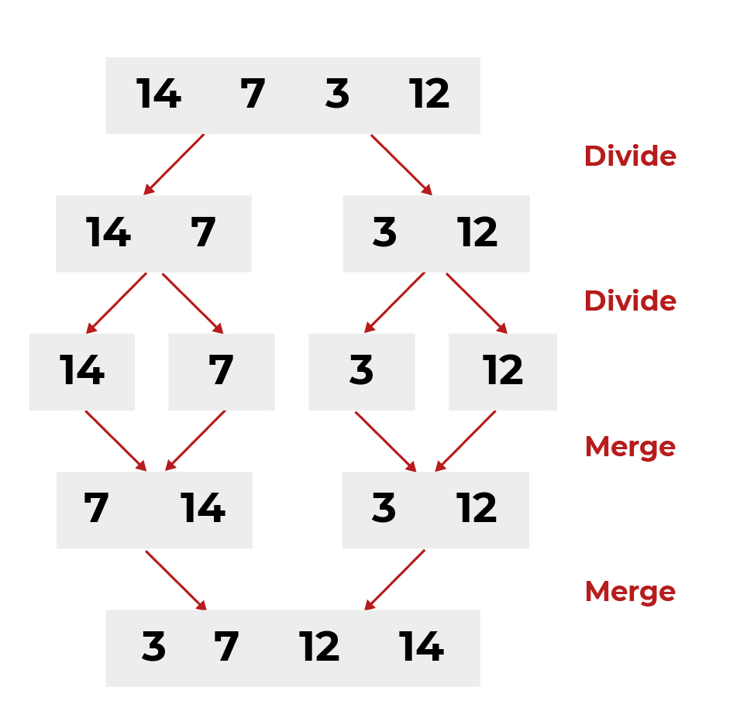

Program 5:

Aim :
To write a python program to implement the Merge Sort algorithm to sort a list of numbers, displaying the list before and after sorting.

Algorithm:
Step 1: Start

Step 2: Define a class MergeSort_ADT

Step 3: Inside the constructor __init__(), initialize an empty list arr

Step 4: Define a method get_input() to insert elements into the array
- Step 4.1: Read the number of elements n from the user
- Step 4.2: Read n elements one by one
- Step 4.3: Store the elements in the list arr
- Step 4.4: Display confirmation message

Step 5: Define a recursive method merge_sort(arr)
- Step 5.1: If the length of arr is less than or equal to 1, return arr
- Step 5.2: Find the middle index using mid = len(arr) // 2
- Step 5.3: Recursively apply merge sort on the left half
- Step 5.4: Recursively apply merge sort on the right half
- Step 5.5: Merge the sorted left and right halves using merge()

Step 6: Define a method merge(left, right)
- Step 6.1: Initialize an empty list result
- Step 6.2: Compare elements of both lists and insert the smaller element into result
- Step 6.3: Add remaining elements from left or right list to result
- Step 6.4: Return the merged sorted list
Step 7: Define a method sort_display()
- Step 7.1: Check whether the array is empty
- Step 7.2: If empty, display “Array is Empty”
- Step 7.3: Else, display the array before sorting
- Step 7.4: Call merge_sort() and display the sorted array

Step 8: Create an object s of the class MergeSort_ADT

Step 9: Define a function rep() for menu-driven operations
- Step 9.1: Display menu options
  - 1 → Enter elements
  - 2 → Sort using Merge Sort
  - 3 → Exit
- Step 9.2: Read the user’s choice
- Step 9.3: Perform the corresponding operation
- Step 9.4: Repeat until the user selects Exit

Step 10: Call the rep() function to start the program

Step 11: Ask the user whether to continue or stop
- Step 11.1: If yes, repeat the process
- Step 11.2: If no, stop the program

Step 12: Stop

Program :
class MergeSort_ADT:
def __init__(self):
self.arr = []

def get_input(self):
self.arr = []
n = int(input("Enter the number of elements: "))
for i in range(n):
item = int(input(f"Enter element {i+1}: "))
self.arr.append(item)
print("Elements inserted successfully")

def merge_sort(self, arr):
if len(arr) <= 1:
return arr

mid = len(arr) // 2
left = self.merge_sort(arr[:mid])
right = self.merge_sort(arr[mid:])
return self.merge(left, right)

def merge(self, left, right):
result = []
i = j = 0

while i < len(left) and j < len(right):
if left[i] <= right[j]:
result.append(left[i])
i += 1
else:
result.append(right[j])
j += 1

result.extend(left[i:])
result.extend(right[j:])
return result

def sort_display(self):
if not self.arr:
print("Array is Empty")
else:
print("Before Sorting:", self.arr)
sorted_arr = self.merge_sort(self.arr)
print("After Sorting :", sorted_arr)

s = MergeSort_ADT()

def rep():
while True:
print("\nGiven Choices are available")
print("1 is Enter Elements")
print("2 is Sort using Merge Sort")
print("3 is Exit the process")
ch = int(input("Enter the Choice: "))

if ch == 1:
s.get_input()
elif ch == 2:
s.sort_display()
elif ch == 3:
print("Exit the Process")
break
else:
print("Invalid Choice")

rep()
while True:
d = input("\nDo you want to continue? (yes/no): ").lower()
if d == "yes":
rep()
elif d == "no":
print("The Merge Sort Process was Stopped!")
break
else:
print("Invalid Typing")

Output:

Given Choices are available
1 is Enter Elements
2 is Sort using Merge Sort
3 is Exit the process

Enter the Choice: 1
Enter the number of elements: 2
Enter element 1: 3
Enter element 2: 1
Elements inserted successfully

Given Choices are available
1 is Enter Elements
2 is Sort using Merge Sort
3 is Exit the process

Enter the Choice: 2
Before Sorting: [3, 1]
After Sorting : [1, 3]

Given Choices are available
1 is Enter Elements
2 is Sort using Merge Sort
3 is Exit the process

Enter the Choice: 3
Exit the Process

Do you want to continue? (yes/no): no
The Merge Sort Process was Stopped!

Result:
The Python program to perform Merge Sort using ADT and menu-driven approach was executed successfully.
------------------------------------------------------------------------------------------------
Quick Sort
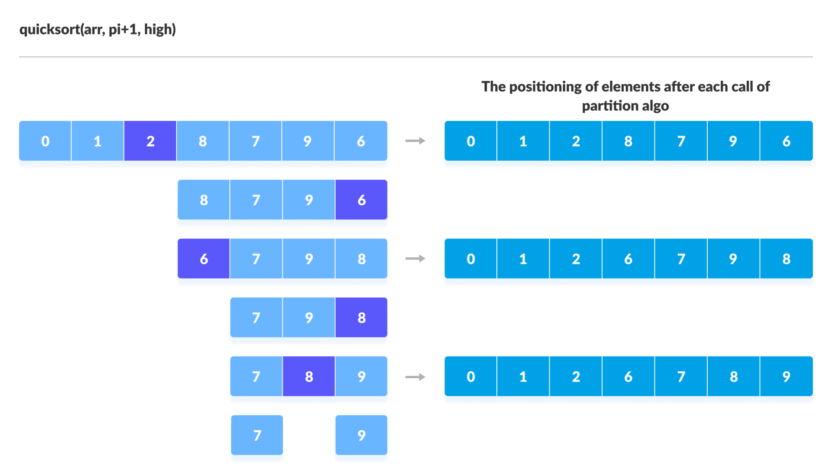
Program 6:
Aim :
To write a python program to implement the Quick Sort algorithm to sort a list of numbers, displaying the list before and after sorting.

Algorithm:
Step 1: Start

Step 2: Define a class QuickSort_ADT

Step 3: Inside the constructor __init__()
- Initialize an empty list arr

Step 4: Define a method get_input()
- Step 4.1: Read the number of elements n
- Step 4.2: Read n elements from the user
- Step 4.3: Store the elements in the array arr
- Step 4.4: Display confirmation message

Step 5: Define a method partition(array, low, high)
- Step 5.1: Select the last element as pivot
- Step 5.2: Rearrange elements so that
  - Elements smaller than pivot are on the left
  - Elements greater than pivot are on the right
- Step 5.3: Return the pivot index

Step 6: Define a recursive method quick_sort(array, low, high)
- Step 6.1: If low < high
- Step 6.2: Find partition index using partition()
- Step 6.3: Recursively apply quick sort on left sub-array
- Step 6.4: Recursively apply quick sort on right sub-array

Step 7: Define a method sort_display()
- Step 7.1: Check whether the array is empty
- Step 7.2: If empty, display message
- Step 7.3: Else, display array before sorting
- Step 7.4: Apply quick sort
- Step 7.5: Display sorted array

Step 8: Create an object of class QuickSort_ADT

Step 9: Define a function rep() for menu-driven operation
- Step 9.1: Display menu options
  - Enter elements
  - Sort using Quick Sort
  - Exit
- Step 9.2: Read the user’s choice
- Step 9.3: Perform the corresponding operation
- Step 9.4: Repeat until user selects exit

Step 10: Ask the user whether to continue
- Step 10.1: If yes, repeat the process
- Step 10.2: If no, stop the program

Step 11: Stop

Program:

class QuickSort_ADT:
def __init__(self):
self.arr = []

def get_input(self):
self.arr = []
n = int(input("Enter the number of elements: "))
for i in range(n):
item = int(input(f"Enter element {i+1}: "))
self.arr.append(item)
print("Elements inserted successfully")

def partition(self, array, low, high):
pivot = array[high]
i = low - 1
for j in range(low, high):
if array[j] <= pivot:
i += 1
array[i], array[j] = array[j], array[i]
array[i + 1], array[high] = array[high], array[i + 1]
return i + 1

def quick_sort(self, array, low, high):
if low < high:
pi = self.partition(array, low, high)
self.quick_sort(array, low, pi - 1)
self.quick_sort(array, pi + 1, high)

def sort_display(self):
if not self.arr:
print("Array is Empty")
else:
print("Before Sorting:", self.arr)
self.quick_sort(self.arr, 0, len(self.arr) - 1)
print("After Sorting :", self.arr)

s = QuickSort_ADT()

def rep():
while True:
print("\nGiven Choices are available")
print("1 is Enter Elements")
print("2 is Sort using Quick Sort")
print("3 is Exit the process")

ch = int(input("Enter the Choice: "))
if ch == 1:
s.get_input()
elif ch == 2:
s.sort_display()
elif ch == 3:
print("Exit the Process")
break
else:
print("Invalid Choice")

rep()
while True:
d = input("\nDo you want to continue? (yes/no): ").lower()
if d == "yes":
rep()
elif d == "no":
print("The Quick Sort Process was Stopped!")
break
else:
print("Invalid Typing")

Output:

Given Choices are available
1 is Enter Elements
2 is Sort using Quick Sort
3 is Exit the process

Enter the Choice: 1
Enter the number of elements: 2
Enter element 1: 5
Enter element 2: 2
Elements inserted successfully

Given Choices are available
1 is Enter Elements
2 is Sort using Quick Sort
3 is Display the Array
4 is Exit the process

Enter the Choice: 2
Before Sorting: [5, 2]
After Sorting : [2, 5]

Given Choices are available
1 is Enter Elements
2 is Sort using Quick Sort
3 is Display the Array
4 is Exit the process

Enter the Choice: 4
Exit the Process

Do you want to continue? (yes/no): no
The Quick Sort Process was Stopped!

Result:

The Python program to sort a given list of elements using the Quick Sort with a menu-driven approach was executed successfully.

----------------------------------------------------------------------------------------------------------

